[Organisation] · STRATEGIC LEVEL
High-Level Strategic Architecture
[Organisation] 2030 — the enterprise-wide target and the sequence to reach it
Field | Detail
Horizon | 2027 to 2030
Version | 0.1 — Draft
Date | April 2027
Owner | Chief Enterprise Architect
Approver | Group Executive Committee, on the Architecture Board's recommendation
Review | Annually, and on any change to the [Organisation] 2030 strategy
Classification | Internal

Contents
1. What this level decides
2. The eight strategic decisions
3. Segments
4. The sequence to 2030
5. What is deliberately not decided here
6. Measures
7. Risks to the strategy
8. Standing and review

This is not the Architecture Vision with more pages
The Vision is per-cycle and scoped to Wave 1. This is the level at which decisions binding on every segment are taken, and it outlives any one ADM cycle. Where the two disagree, this document is the frame and the Vision is the instance.

1. What this level decides
Three levels of architecture, each deciding different things on a different horizon and approved by a different body.
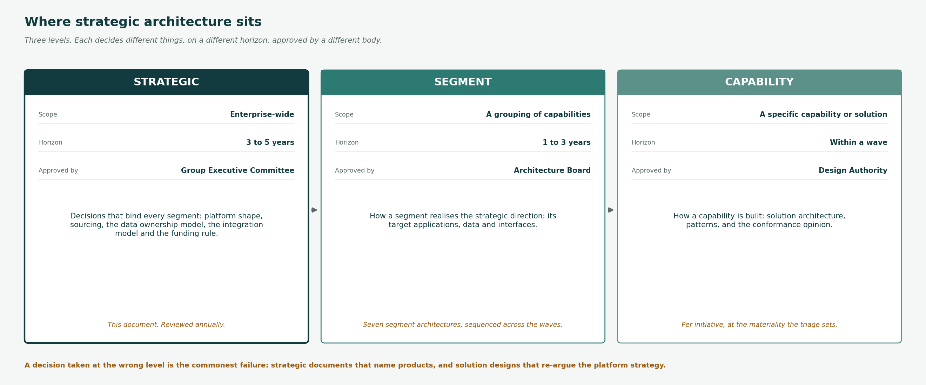
Figure 1 — Strategic, segment and capability. A decision taken at the wrong level is the commonest failure mode.

Level | Scope | Horizon | Approved by | What it decides
Strategic | Enterprise-wide | 3 to 5 years | Group Executive Committee | Decisions that bind every segment: platform shape, sourcing, the data ownership model, the integration model and the funding rule.
Segment | A grouping of capabilities | 1 to 3 years | Architecture Board | How a segment realises the strategic direction: its target applications, data and interfaces.
Capability | A specific capability or solution | Within a wave | Design Authority | How a capability is built: solution architecture, patterns, and the conformance opinion.

2. The eight strategic decisions
These bind every segment. A segment architecture that departs from one of them requires a dispensation, recorded and time-bound.

SD-01 Contain the legacy estate; do not replace it
LIFE/400 and the short-term platform are wrapped behind managed interfaces. Capability moves off them incrementally.
Recorded in | Why this and not the alternative
ADR-031, ADR-034 | Two core replacements have already failed. A third attempt is the specific outcome this decision exists to prevent.

SD-02 Resolve customer identity by match-and-link, not consolidation
A hub resolves identity across the four masters. No master is replaced, and no fifth master is created.
Recorded in | Why this and not the alternative
ADR-031 | Consolidation requires all four sources to change at once, which is the shape of the 2021 failure.

SD-03 All new integration is routed, authenticated and logged
The managed integration layer is the only route for new integration. File transfer and direct database reads are not extended.
Recorded in | Why this and not the alternative
ADR-033 | Forty-four of sixty interfaces are unmanaged. Without this rule every new integration makes the position worse.

SD-04 Rating and product configuration sit outside policy administration
Rating factors are externalised so a rate change does not require a platform release.
Recorded in | Why this and not the alternative
ADR-032 | Eleven weeks to reprice motor against a market that moves in days is an architecture constraint, not a pricing one.

SD-05 Buy conduct and regulatory evidence capability; do not retrofit it
Conduct outcome evidence and lineage are acquired as capability rather than built onto systems that were not designed for it.
Recorded in | Why this and not the alternative
COA-04 | Retrofitting evidence onto LIFE/400 was estimated at more than the acquisition, with a worse result.

SD-06 The subsidiaries stay federated
[Organisation] Namibia and [Organisation] Botswana set their own architecture. Group sets interoperability, not design.
Recorded in | Why this and not the alternative
ADR-037 | They operate under different regulators. Binding them to group design would create obligations group cannot discharge.

SD-07 Data is placed in-country by default
Personal data of South African data subjects is processed and stored in South African regions unless a transfer basis exists.
Recorded in | Why this and not the alternative
ADR-035 | POPIA section 72. Placement decided at design rather than discovered at deployment.

SD-08 Change is funded from run-cost reduction
No incremental budget before FY2028. A work package without a named funding source is not scheduled.
Recorded in | Why this and not the alternative
COA-10 | This is a constraint rather than a preference, and stating it as a decision keeps it visible.

3. Segments
Seven segment architectures sit beneath this document. Each realises the strategic decisions within its own scope and is approved by the Architecture Board.

Ref | Segment | Waves | Capabilities | Principal content | Owner
SEG-01 | Customer and Distribution | Wave 1 to 2 | Customer Management, Distribution & Channel | Identity hub, broker submission API, channel model | Chief Distribution Officer
SEG-02 | Underwriting and Product | Wave 2 | Market & Product Management, Underwriting & Risk Selection | Rating service, product configuration, referral rules | Chief Underwriting Officer
SEG-03 | Policy Servicing and Administration | Wave 2 to 3 | Policy Servicing & Administration, Billing & Collections | Servicing desktop, collections, the life platform decision | Claims and Servicing Executive
SEG-04 | Claims | Wave 1 to 2 | Claims Management | One claims workflow, parlour portal, recovery and leakage | Claims Executive
SEG-05 | Finance, Actuarial and Regulatory Reporting | Wave 2 to 3 | Finance & Actuarial, Risk Compliance & Financial Crime | IFRS 17 sub-ledger, conduct evidence, obligation traceability | Chief Financial Officer
SEG-06 | Data and Analytics | Wave 1 to 3 | Data & Analytics | Authoritative sources, lineage, the data platform | Chief Data Officer
SEG-07 | Enterprise Technology and Security | All waves | Enterprise Enablement | Integration layer, resilience tiering, identity and access | Chief Information Officer

4. The sequence to 2030
Three waves. Each leaves a transition state [Organisation] can stop at, which is the direct answer to two prior failed transformations.
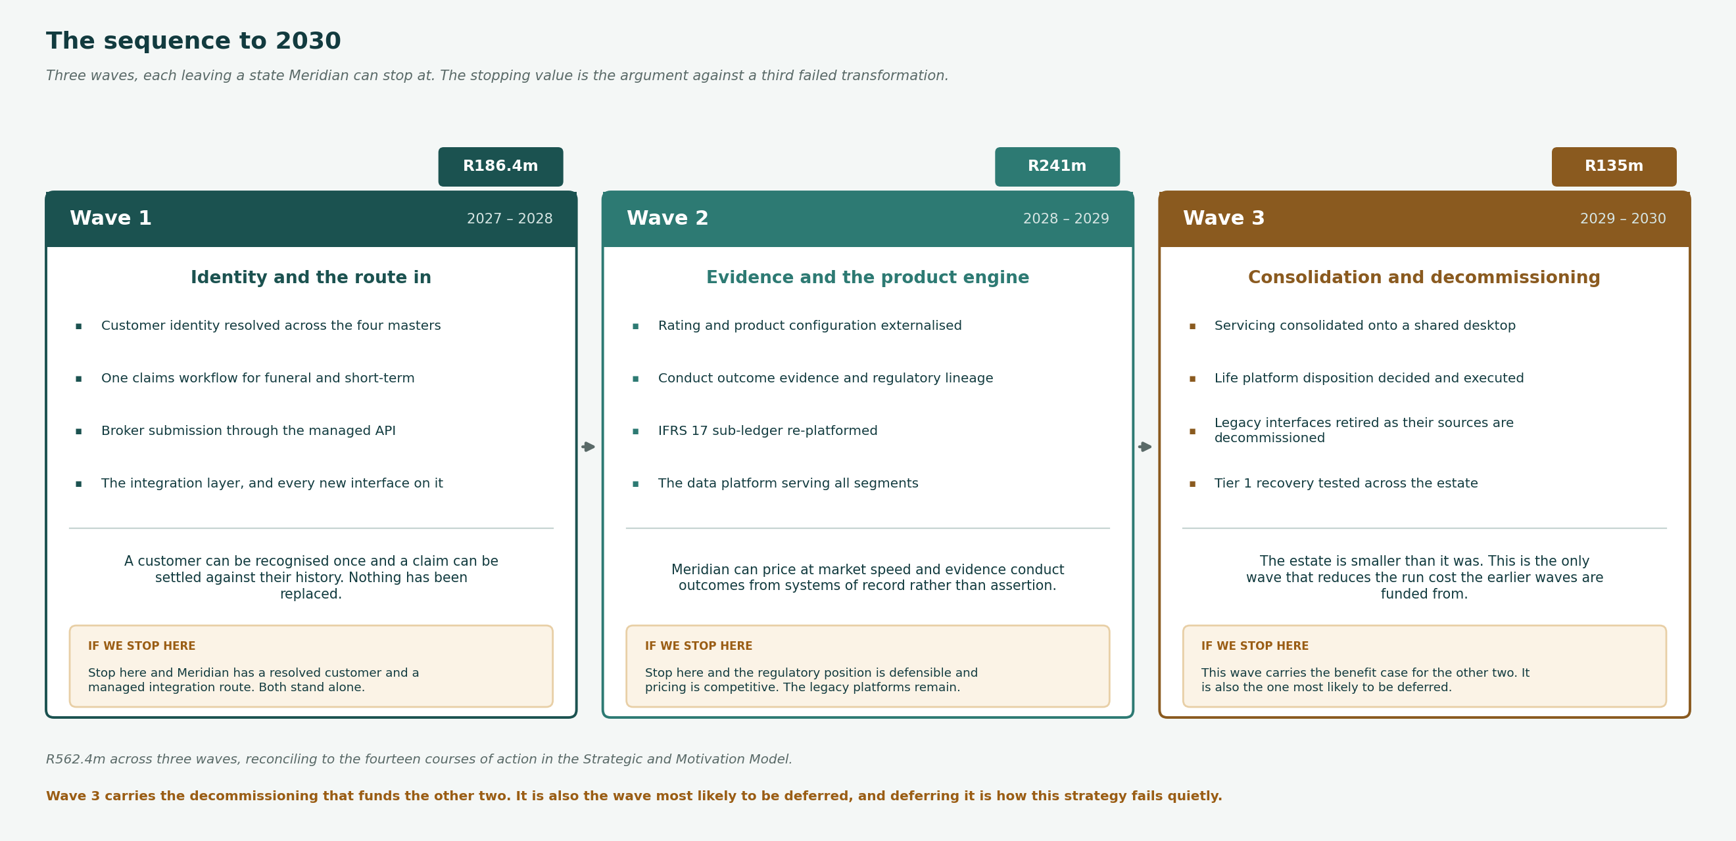
Figure 2 — The three waves, what each delivers, and what stopping after it would leave.

Wave | Period | Theme | End state | Cost
Wave 1 | 2027 – 2028 | Identity and the route in | A customer can be recognised once and a claim can be settled against their history. Nothing has been replaced. | R186.4m
Wave 2 | 2028 – 2029 | Evidence and the product engine | [Organisation] can price at market speed and evidence conduct outcomes from systems of record rather than assertion. | R241m
Wave 3 | 2029 – 2030 | Consolidation and decommissioning | The estate is smaller than it was. This is the only wave that reduces the run cost the earlier waves are funded from. | R135m

Wave 3 is the one that matters and the one most likely to be deferred
Wave 3 carries the decommissioning that reduces the run cost the first two waves are funded from. Deferring it leaves [Organisation] with more estate than it started with, funded by a saving that never arrived. That is how this strategy fails quietly rather than loudly.

5. What is deliberately not decided here
Five things. Naming them prevents the document being read as more binding than it is, and prevents the same argument being had at three levels.

Not decided here | Decided at | Why
Products and vendors | Segment or Phase D | No product is named at this level. Naming one forecloses the standards assessment and dates the document.
Solution design | Capability level | How a capability is built is a solution architecture question, taken at the materiality the triage sets.
Sequencing within a wave | Phase E | The waves are strategic. What runs in which quarter inside a wave is portfolio planning.
Organisational structure | Not an architecture decision | Who operates the claims workflow is a real question with a real owner, and that owner is not the architect.
The life platform disposition | Wave 3, deliberately deferred | Deciding it now would be deciding it without the data the first two waves produce. CR-014 is open for this reason.

6. Measures
Enterprise-level, over the full horizon. Wave-level indicators are in the Architecture Vision.

Measure | Baseline | Target | By | Owner
Capabilities at target maturity | 18 of 134 | 95 of 134 | 2030 | Chief Enterprise Architect
Applications in the estate | 142 | 108 | 2030 | Application Domain Architect
Interfaces under management | 16 of 60 | 60 of 60 | 2030 | Chief Information Officer
Run share of technology spend | 71% | 60% | 2029 | Chief Information Officer
Customer records resolved to one identity | 62% | 95% | 2030 | Chief Data Officer
Conduct outcomes reportable from source | 12% | 90% | 2028 | Chief Compliance Officer

7. Risks to the strategy
Risk | Likelihood | Impact | Response | Owner
Wave 3 is deferred and the benefit case never lands | High | Severe | Wave 3 carries the decommissioning that funds the other two. Deferring it is the most likely way this strategy fails quietly. | Group Chief Executive
The strategy outlives the assumptions it rests on | Medium | High | Reviewed annually and on any change to [Organisation] 2030. A strategic architecture that is not reviewed becomes a record of what the firm used to intend. | Chief Enterprise Architect
Segment architectures diverge from the strategic decisions | Medium | High | The eight strategic decisions are enforceable through the conformance opinion at G2. Divergence is a dispensation, recorded and time-bound. | Architecture Board
Containment becomes permanent avoidance | Medium | High | Containing legacy is a strategy, not an outcome. Wave 3 exists to convert containment into decommissioning, and its deferral is the tell. | Chief Information Officer

8. Standing and review
The strategic architecture makes eight decisions and defers five. Its purpose is to be the thing segment and capability architectures are checked against, which means it is only useful while those eight decisions are enforceable. Until the Architecture Board is constituted they are recommendations, and this document is a proposal rather than a position.

Question | Answer
Who approves | Group Executive Committee, on the Architecture Board's recommendation
How often reviewed | Annually, and on any change to the [Organisation] 2030 strategy
What triggers a change | A strategic decision proving unworkable, a wave being deferred, or a material change in the regulatory position
Where it is held | Architecture Repository, 03_Architecture_Landscape/01_Strategic_Architecture
Standing today | Recommendation. The Architecture Board has not been constituted, so none of the eight decisions is yet enforceable.

Related documents
- Business Motivation Model — the goals these decisions serve
- Architecture Vision — the Wave 1 instance of this frame
- Business Capability Map — the capabilities the segments group
- Architecture Roadmap — the sequencing within each wave

